<Project 1. System call> So hyun Park / 2015310884 / Philosophy major

I will explain the change or input of codes in time order.

1. user.h

I added below code in system calls section.

void ps(int pid);

int getnice(int pid);

int setnice(int pid, int value);

I had to match the format of return and arguments for using in user level.

2. usys.S

I inserted below codes meaning that ps, getnice, and setnice are all system calls.

SYSCALL(ps)

SYSCALL(getnice)

SYSCALL(setnice)

3. syscall.h

I assigned system call numbers like,

#define SYS_ps 23

#define SYS_getnice 24

#define SYS_setnice 25

4. syscall.c

I added below codes to use system calls in other files.

In definition,

extern int sys_ps(void);

extern int sys_getnice(void);

extern int sys_setnice(void);

and in structure,

[SYS_ps] sys_ps,

[SYS_getnice] sys_getnice,

[SYS_setnice] sys_setnice

5. defs.h

I also added functions in this file to use in proc.c file.

void ps(int pid);

int getnice(int pid);

int setnice(int pid, int value);

6. proc.h

I added a member 'nicevalue' related with priority in struct proc.

struct proc {

...

int nicevalue;

...

}

Until now, those were preliminary works.

7. sysproc.c

I think this part is very important, because this phase plays a role like a bridge between system and user. Through sys function, ps, getnice, setnice are called. So, ps(pid) matches with void, getnice(pid) matches with int, setnice(pid, value) matches with int each.



Other skills are explained in comment above. To be specific, to return void, I had to use only argint(0, &pid); in sys_ps, different from sys_getnice and sys_setnice because if(argint(0, &pid) < 0); return -1; way caused error.

8. proc.c

This is final step, and also important because real operations are realized in this part.

In this section, I realized that acquire is needed to access struct proc *p, and the authority should be handed in after using it. If not writing 'release' function in the end, errors occur. I branched the case when showing all processes(pid is 0) and other case when showing process information only corresponding pid, and the other case when there is no corresponding pid, which prints nothing.

- allocproc 함수에 p->nicevalue = 20; 추가





getnice function has similar way of acquire and release explained before. This function divides case when returns nicevalue, and the other case when returns -1, which means there is no process corresponding pid.



setnice function also has a same way of accessing the structure proc *p. In this step, I had to release carefully every time before return, because missing release caused terrible errors like that.

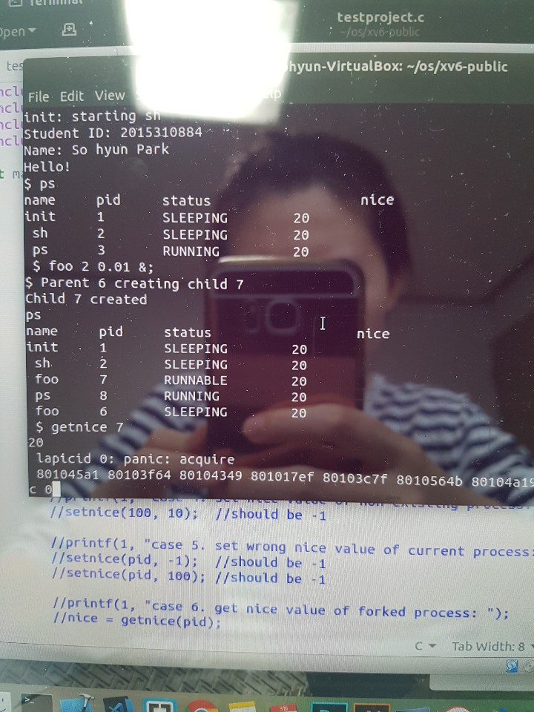

9. Test

I made testpj.c with below codes and inserted _testpj⧵ in make file.



The execution result shows that it works well.

